STRUCTURED QUERY LANGUAGE
ASSIGNMENT – 1
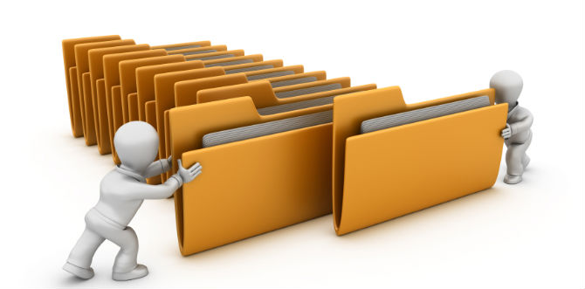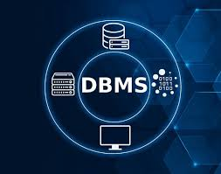

AAFT, SCHOOL OF DATA SCIENCE
COURSE-BS.C ARTIFICIAL INTELLIGENCE
NAME-MEHAR MARWAH
ROOM NO.-LAB NO.8

TABLE OF CONTENTS
- INTRODUCTION TO SQL
2.IMPORTANCE OF DATABASE MANAGEMENT SYSTEM
3.DBMS VS TRADITIONAL FILES
4. AN INTRO TO SQL COMMANDS
5. ABSTRACTION VS SCHEMA

INTRODUCTION TO SQL
WHAT IS SQL ?
There are several numbers of database query languages in use like Cypher, GraphQL, XQuery etc, either commercially or experimentally. SQL is one of them.
Although we refer to SQL as “query language”, it can do much more than just query a database and specify security constraints.

OVERVIEW OF SQL QUERY LANGUAGE :
IBM developed the original version of SQL, originally called Sequel, as part of the System R project in the early 1970’s . This language has evolved since then and now it’s named as SQL or Structured Query Language .It has established itself as standard relational database language as now many products support SQL language .
In 1986 the American National Standards Institute (ANSI) and the International Organization for Standardization (ISO) published an SQL standard called SQL-89 in 1989.
Later , the next version of standard was published called SQL-92 followed by SQL-1999 , SQL-2003 , SQL-2006 and SQL-2008.
It has several parts such as :-
1.DDL – Data Definition Language
2. DDL
3. DQL
4.DML-Data Manipulation language
5.Transaction control

IMPORTANCE OF DATABASE MANAGEMENT SYSTEM
WHAT IS DBMS ?
A DBMS is a collection of interrelated data and a set of programs to access those data.
The collection of data , usually referred to as database information relevant to an enterprise . The primary goal of DBMS is to provide a way to store and retrieve database that is both convenient and efficient.
IMPORTANCE OF DATABASE:
IT is designed to manage large bodies of information.
- IT is used for storing and retrieving information conveniently and efficiently.
- It helps in managing large bodies of data
- IT helps in defining structures for storage and manipulation.
- Ensuring safety of information against crashers or unauthorized access.
- It also helps in avoiding anomalous results when data is shared among several users .

What are traditional files ?
Traditional files were used for data storage and retrieval before databases.
It is a method of storing and managing data in individual files. These files are organized in directories or folders on a computer’s storage device .In this system each file is designed to store data related to specific purpose example bank transactions and customer records but not inherently connected to specific files.
The data here is accessed, updated, or updated manually by custom records.
Before the use of computer, a manual file system was used to maintain files and records . It was stored and processed using a traditional file system and it makes easy access to find any information.
In traditional file system , each file is independent of other files, and data in the file can be integrated only by writing an individual program for each application.
WORKING OF A TRADITIONAL FILE :
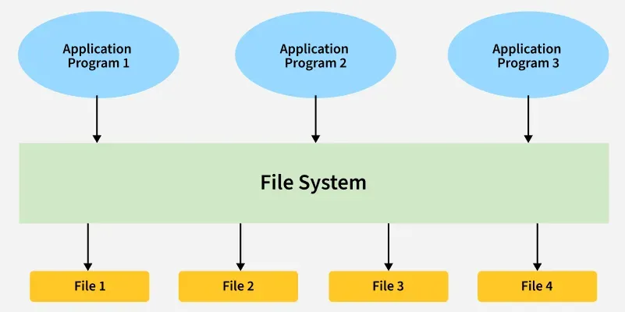

DBMS VS TRADITIONAL files :
DBMS  1.It is a collection of data. In DBMS the user is not required to write the procedures such as Data Consistency, Security and access control and etc.  2. In DBMS users don’t see all the raw details of how data is actually stored in database.  3.It provides a good protection mechanism .  4.It has a wide variety of techniques to store and retrieve the data.  5.Reduncy is control in DBMS.  6.Unauthorized access is restricted in data.  7.It is made to allow flexible access to data.  8.It helps to coordinate i.e accessing the same data at the same time. | TRADITIONAL FILES  1.In Traditional file system data and program are inter-dependant.  2.It can cause data redundancy i.e The data may be duplicated in different files.  3.It also causes data inconsistency i.e data files may be different that cause data inconsistency.  4.It cannot be sared as it is stored in different files.  5.It does not provide consistency constraints.  6.It is a less complex system.  7.It takes more space and more memory is waisted.  8.To generate different report to take a crucial decision .

An introduction to sql commands :
There are 5 types to sql commands :
1.DDL

Data definition language commands are employed for creating, modifying and deleting database objects.
It contains 4 things:
- CREATE :IT builds new database objects , CREATE TABLE EMPLOYEE(…)
- ALTER: Modifies existing objects ALTER TABLE Employees ADD Phone;
- DROP : Drop table employees
- TRUNCATE : Removes all rows from a table, retaining structure TRUNCATE Table Logs ;
2.DML
Data manipulating Language commands are used for managing data with database objects.
IT Has 3 Objects
- INSERT
IT adds new rows of data into a table INSERT INTO Products Values (…)
- DELETE
Removes rows from a table
DELETE FROM Customers WHERE Region=’North’;
- UPDATE
Modifies existing data in a table
UPDATE Orders SET
Status=’Shipped’ WHERE
ID=1;
3.DQL
Data Query Language is primarily focused on the ‘SELECT Command for fetching data from databases.
IT HAS 3 THINGS:
- SELECT Column FROM TABLE
Basic data retrieval
- SELECT…WHERE CONDITION
Filtering data based on criteria
- SELECT…JOIN…ON
Combining data from multiple tables.
3.DCL AND TCL

DCL  DATA CONTROL LANGUAGE:  MANAGES DATABASE permission and access.  GRANT: Provides user across privileges .  REVOKE : Removes user access privileges. | TCL  TRANSACTION CONTROL LANGUAGE:  Manages statements by DML statements  COMMIT:Saves changes permanently  ROLLBACK : Undoes changes since last commict  SAVE POINT: Sets a point to roll back to.

CONCEPT OF Data abstraction and independence :
DATA ABSTRACTION
Data Abstraction is the process of hiding complex implementation details from the user. Its purpose is to provide users with a simplified , relevant view of the data , focusing on “what” data is needed rather than “how” it’s stored or manipulated .
DATA INDEPENDENCE
Data Independence is the ability to modify the scheme at one level of the database system without affecting the schema at the next higher level. Its core purpose is to protect applications from structural changes in the database system.

Q2) Commands in Sql:
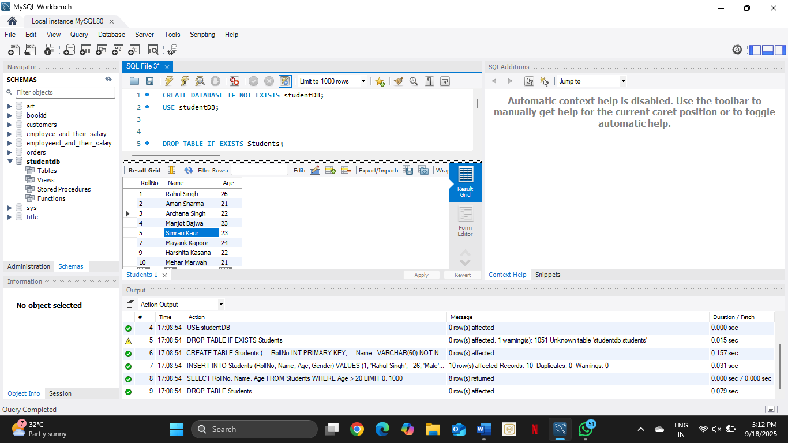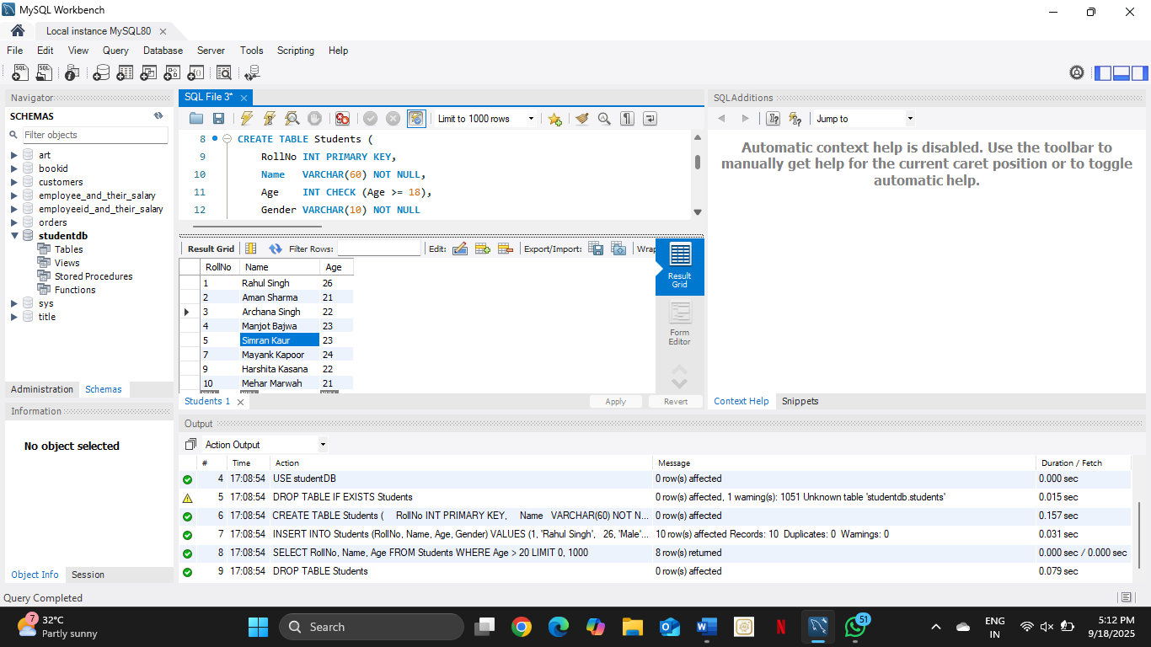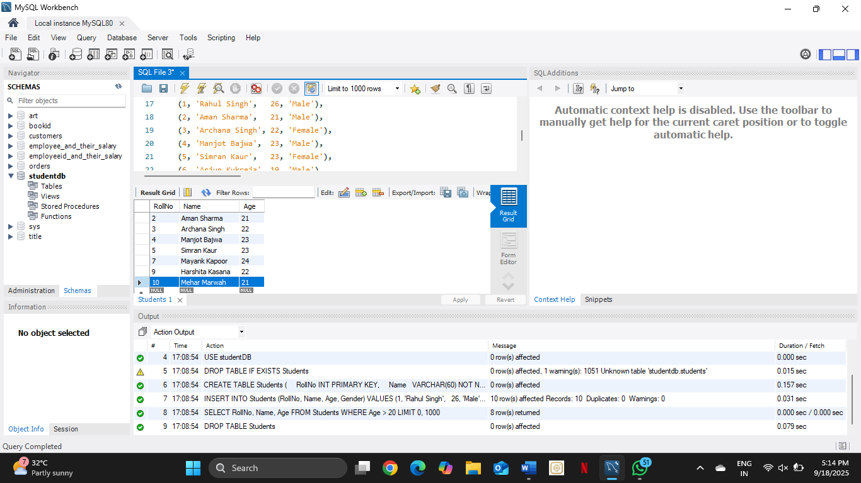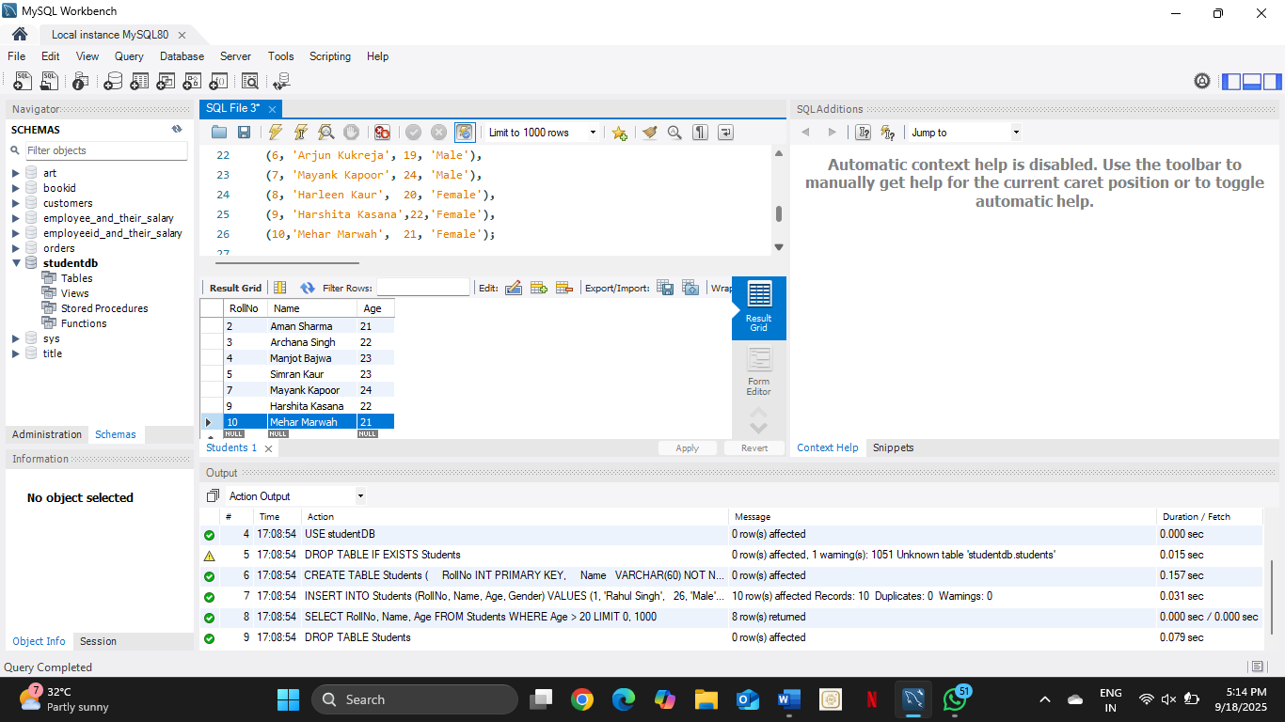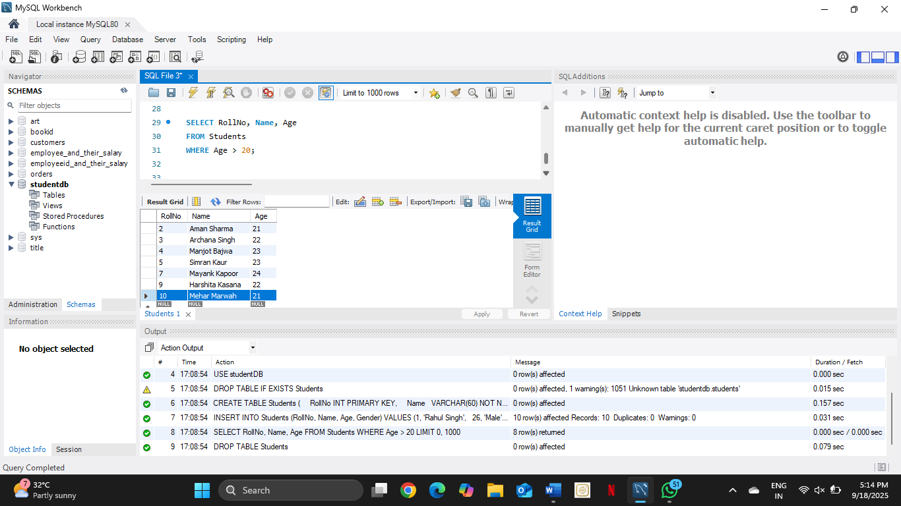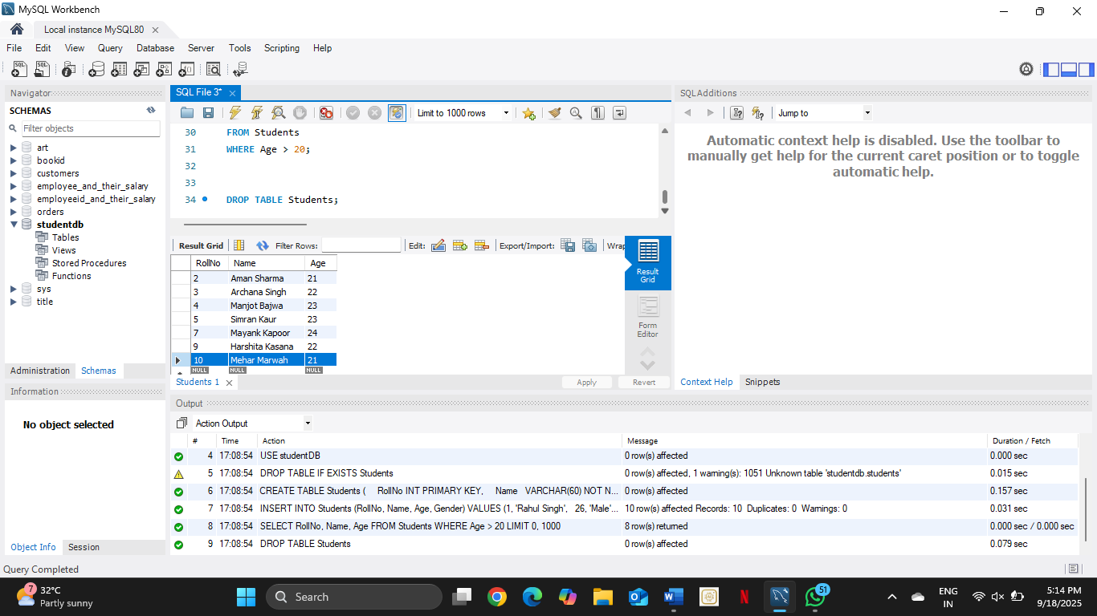

THANK YOU

